EXP.NO:3
Aim
To write and execute a C program to implement the Polyalphabetic Substitution Cipher (Vigenère Cipher) for encrypting and decrypting a given message using a keyword.
Algorithm
Encryption
- Start the program.
- Read the plaintext from the user.
- Read the keyword.
- Repeat the keyword until it matches the length of the plaintext (ignoring spaces).
- For each alphabetic character:
  - Convert both plaintext and keyword letters to numerical values (A = 0, B = 1, ..., Z = 25).
  - Add the values and take modulo 26.
  - Convert the result back to a character.
- Display the encrypted text.
Decryption
- For each alphabetic character in the ciphertext:
  - Convert the ciphertext and keyword letters to numerical values.
  - Subtract the keyword value from the ciphertext value.
  - If the result is negative, add 26.
  - Convert the result back to a character.
- Display the decrypted text.
- Stop the program.
PROGRAM:
#include <stdio.h>
#include <string.h>
#include <ctype.h>

int main()
{
char plain[100], key[100], cipher[100], decrypt[100];
int i, j, keyLen;

printf("Enter Plain Text: ");
fgets(plain, sizeof(plain), stdin);
plain[strcspn(plain, "\n")] = '\0';

printf("Enter Keyword: ");
scanf("%s", key);

keyLen = strlen(key);

// Encryption
j = 0;
for(i = 0; plain[i] != '\0'; i++)
{
if(isalpha(plain[i]))
{
char p = toupper(plain[i]);
char k = toupper(key[j % keyLen]);

cipher[i] = ((p - 'A') + (k - 'A')) % 26 + 'A';
j++;
}
else
{
cipher[i] = plain[i];
}
}
cipher[i] = '\0';

printf("\nEncrypted Text: %s\n", cipher);

// Decryption
j = 0;
for(i = 0; cipher[i] != '\0'; i++)
{
if(isalpha(cipher[i]))
{
char c = toupper(cipher[i]);
char k = toupper(key[j % keyLen]);

decrypt[i] = ((c - 'A') - (k - 'A') + 26) % 26 + 'A';
j++;
}
else
{
decrypt[i] = cipher[i];
}
}
decrypt[i] = '\0';

printf("Decrypted Text: %s\n", decrypt);

return 0;
}
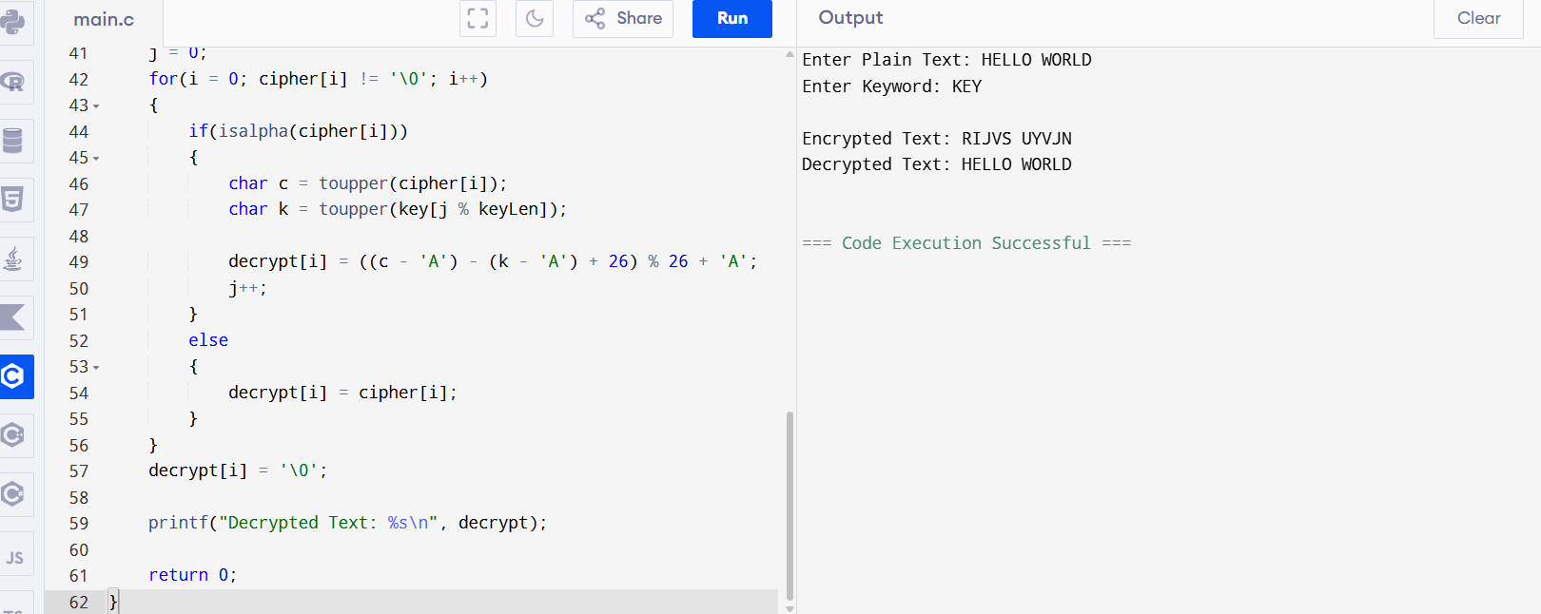
RESULT:
VIGNERE cipher algorithm executed successfully.

